**Level Design Document for:**

**Zombie Platformer**

All work Copyright ©2021

Written by James Webster

Table of Contents

1.0 Revision History 3

2.0 level Design Overview 3

2.1 Level Design concept 3

2.2 Gameplay Mechanics 3

2.3 Camera 4

3.0 Theme and Characters 4

3.1 Characters 4

3.2 Theme 4

4.0 Level Information 4

4.1 Level Location 4

4.2 Level Setting 4

4.3 Level Layout/Architecture 4

5.0 Level Design 5

5.1 Main Objectives 5

5.2 Optional Objectives 5

5.3 WOW Moments 5

5.4 Level Progression 5

5.5 Player Experience 5

6.0 Art Style and Aesthetics 6

6.1 References 6

6.2 Lighting 6

6.3 SFX/Music 6

6.4 Particle FX 6

7.0 Level Asset List 7

8.0 Iteration and Results 8

# 1.0 Revision History

<As you revise the document, list what was changed and when it was changed>

|  |  |
| --- | --- |
| Version | Description |
| 1.0 | Initial Template |
| 1.1 | Updated Asset List |
| 1.2 | Updated Environment/Lighting |
| 1.3 | Updated Environment Elements |
| 1.4 | Fleshed out ‘Iteration and Results’ |

# 2.0 Level Design Overview

## 2.1 Level Design concept

The player is placed on a flat platform held up by supports in a construction site. Zombies spawn in regular intervals across the map, and a certain number of zombies must be killed in order to pass the level. This can be done by either shooting the zombies or leading them off the level.

## 2.2 Gameplay Mechanics

* **Movement:** 
  + WASD controls
  + Short Jump
* **Player UI:**
  + Player ‘Health’ displayed
  + Current ‘Kill Count’ displayed
* **Gun:**
  + Always shoots on a horizontal trajectory
  + Slow fire-rate
  + One-shot kill
* **Moving Platforms:**
  + Linear movement back and forth
* **Kill Floor:**
  + Instantly kills both player and zombies
  + Covers map below level

## 2.3 Camera

* **Third-person** perspective (behind the player)
* Follows **Player Mouse** movements

# 3.0 Theme and Characters

## 3.1 Characters

* **Player:** Grey/green bean shape up-right
* **Zombie:** Green bean shape up-right

## 3.2 Theme

* Dark/Colourful aesthetic
* Survival game, employing action and problem-solving skills

# 4.0 Level Information

## 4.1 Level Location

* A high platform held by support beams from the construction site below.
* A block of land within the torn city, surrounded by tall, traditional residential buildings

## 4.2 Level Setting

* Dark, opaque colour palette across all assets
* Spotlights surrounding the site illuminate most of the platform.
* Artificial green lights scattered attached to the moving platform.
* Fire spewing out from the surrounding buildings.

## 4.3 Level Layout/Architecture

* Approx. three quarters of the traversable level will consist of a large, flat platform held up by support beams.
* A large gap in the level will make space for the moving platform.
* Platforms will repeat a linear path from point A-B-A
* Ramps will act as an obstacle for the player.
* Guard rails will surround the entire level, except for the hole with the moving platform.

# 5.0 Level Design

## 5.1 Main Objectives

The goal is to kill a certain number of zombies by any means necessary.

## 5.2 Optional Objectives

* Kill zombies using gun.
* Kill zombies by luring them into the kill floor.

## 5.3 WOW Moments

A final wave of zombies will appear immediately after the kill cap is reached, acting as the final challenge.

## 5.4 Level Progression

The rate of zombies spawning will slowly increase overtime.

## 5.5 Player Experience

The difficulty curve created from the spawning zombies and the increasingly complex problem solving necessary to complete the level.

# 6.0 Aesthetics

## 6.1 References

## 6.2 Lighting

* Dominant use of spotlights from cranes across the level (no roof)

## 6.3 FX

* Sound bites for zombie death, gun shots and player damage
* Flames from the Moving Platform’s thrusters

# 7.0 Level Asset List

|  |  |  |  |  |  |
| --- | --- | --- | --- | --- | --- |
| **Assets** | **Description** | **Dimensions** | **Poly/Tri Count (max)** | **Texture Resolution** | **Status** |
| **Static/Environment** |  |  |  |  |  |
| Floor Tile | Used for **building** floor | 1 x 0.25 x 1 Cube | 6 | 1024 x 1024 | Done |
| Guard Rail (side) | Metal pipes, **Seamless** attachment to Side and Corner Guard Rail | 0.25 x 0.5 x 1 Cube/Cylinders | 500 | 512 x 512 | Done |
| Guard Rail (corner) | **Bent** metal pipes, **Seamless** attachment to Side and Corner Guard Rail | 0.25 x 0.5 x 1 Cube/Cylinders | 600 | 512 x 512 | Done |
| Ramp | Wide enough to support both **player and zombies** to traverse | 1 x 2 x 3 Cube | 7, 2 | 512 x 512 | Done |
| Building 1 | City residential building, **slightly taller** than the platform | 25 x 50 x 25 Cube | 6 | 1024 x 1024 | Done |
| Building 2 | City residential building, **taller than** the platform | 25 x 70 x 25 Cube | 6 | 1024 x 1024 | Done |
| Construction Site | Space below the player with **lights and construction Assets** | 25 x 1 x 25 Cube | 6 | 1024 x 1024 |  |
| Block of Land | A **measurement of the ground** the environment is placed on | 25 x 1 x 25 Cube | 6 | 512 x 512 |  |
| Fence | Placeholder walls **placed around the Construction** Site | 0.5 x 2.5 x 4 Cube | 12 | 256 x 256 |  |
| Scaffold Beams | A **placeholder beam** which will stack on top of each other | 1.5 x 5 x 1.5 Cube | 120 | 256 x 256 |  |
| Support Beam | A beam which can be stacked into **a pile on the ground** | 12 x 1 x 1 Cube | 6 | 256 x 256 |  |
| Dump Truck | A large construction **dump truck with dirt in the back** | 4 x 5 x 15 | 250 | 512 x 512 |  |
| Spotlights | Spotlights littered around the construction site | 0.5 x 7.5 x 0.5 Cube | 30 | 256 x 256 |  |
| Crane | Parallel to platform, arm stretched with lights | 35 x 47.5 x 3 | 300 | 512 x 512 | Done |
| **Characters** |  |  |  |  |  |
| Zombie (body) | Body size **related to head size**, has simple arms | 0.5 x 1.5 Boolean | 500 | 512 x 512 | Done |
| Zombie (head) | **Exaggerated facial** features | 0.5r Sphere | 300 | 512 x 512 | Done |
| Player (body) | Arms positioned for gun | 0.5 x 1.5 Boolean | 50 | 512 x 512 | Done |
| Player (gun) | Basic **pistol** shape | 0.5 x 0.5 x 0.5 Cube | 450 | 256 x 256 | Done |
| Player (head) | **Tactical helmet** on head | 0.5r Sphere | 300 | 512 x 512 | Done |
| **Feature** |  |  |  |  |  |
| Moving Platform | **Detailed** elements, rocket **underneath** | 1.5 x 0.25 x 1.5 Cube | 1000 | 2048 x 2048 | Done |

# 8.0 Iteration and Results

**First Greybox:**

* Diagram

  Description automatically generatedSimple building blocks were put together in Maya and imported in Unity to roughly box out the concept drawing for the level. This led to me increasing the expected size of the level in order to fit ramps and reasonable pathways.

**Version 1.0**

* The small-scaled platform lent itself well to the limited number of zombies spawning, on top of the speed of the platform encouraging the player to use it. All basic assets had been named, modelled and textured. However, the AI wasn’t perfect at this point, so not all outset mechanics could be tested immediately. The first testers pointed out some of the most glaring flaws of the Greybox, including no indication of a consistent reload time, a clear objective, a dominant theme or obvious feature asset.

**Version 1.1**

* Small additions to gameplay were the main concern of this iteration. A gun flip animation was added to simulate reloading, customizable scripts for zombie spawners and the level manager and the first test of particle effects. It was only after these additions I was reminded that the level couldn’t just float in a space, but had to be built into an environment, resulting in me going back through my documents for inspiration and ideas for this environment.

**Version 2.0**

* The final iteration of the game encompassed a big leap in terms of environment building, scripting, lighting, texturing, particle effects and fundamental game mechanics. Upon rigorous testing and evaluation, I decided on fleshing out a torn city amid a zombie apocalypse. A skybox was implemented to assist the effect of lighting, zombies spawned from above rather than out of nowhere, the feature asset was retextured to match the level’s aesthetic and further customization of zombie attributes, behavior and pathing was achieved. As a result of this jump, many testers were satisfied with the game’s difficulty and art style.

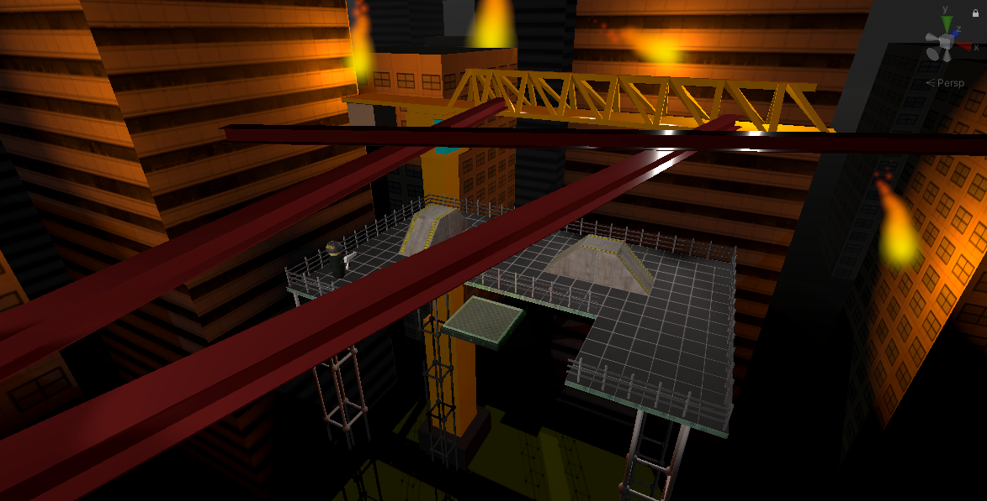

## Fall Guys: Ultimate Knockout Review – Takeshi's Castle: Jelly Bean Edition! | DigitOvercooked 2 Review | NDTV Gadgets 360

# 